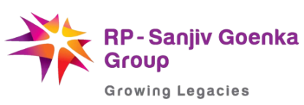

International Management Institute Kolkata
in collaboration with
Sichuan Academy of Social Sciences
is organizing an international conference on
India, China and the New World Order:
Economic, Social and Cultural Dimensions
November 24-25, 2016
IMI Kolkata Campus

Registration Form

- Name :
- Designation:
- Institute/ Organisation Name and Address:

- Are you an Author Attendee (Please Tick)

- Phone Number:

- Email ID:

- Choice of Food : Veg ______ Non-Veg ______

- Would you be attending the Networking Dinner? Yes/No: Yes

- Payment details:
Amount: Paid via Card/RTGS:
Date of Deposit:
Order No. : 1447928610144
Tran. Ref. No. :
Please send your filled up registration form to chindia@imi-k.edu.in

